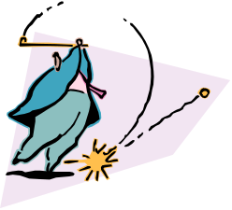
What is a Force?

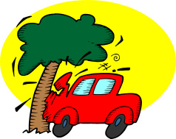
We cannot see ___ force. We can only see _____ effects of the force ___ what the force ____ doing. If there are no forces ______ stationary objects _____ remain still, and objects moving ___ a steady speed will continue to do ____ in a straight line.
or, a, then, so, the, is, at, will,

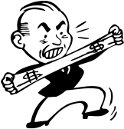
To make ____ object start moving ____ to stop it from moving, we must push or pull on ____. The pushes _____ pulls are called forces. Lifting, bending, __________, squeezing, twisting and tearing ___ involve the use of a force.
it, an, and, or, all, stretching

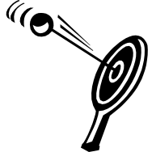
A force may _____change the shape of ____ object. By pushing against the sides of __ cardboard box we ____ able to change ____ shape. The impact of a car _____ a power pole can cause forces which change _____ shape of both the car _____ the power pole.
an, its, also, are, a, the, with, and

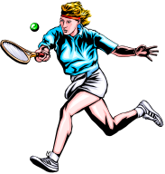
Forces _____ also change the direction in which ____ object is moving. When a tennis player returns ____ ball during __ game, the force ____ the tennis racquet on the ball causes the ball ___ change direction.
can, the, an, to, of, a

If ___ slow moving pool ball ___ pushed from behind ____ another pool ball then it will continue ___ move in the same direction but ___ a faster speed. This happens because a force _____ change the speed of something ______ is already moving. The larger ____ force, the greater the change ____ speed.
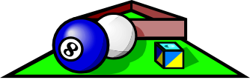
to, a, by, at, is, of, can, that, the

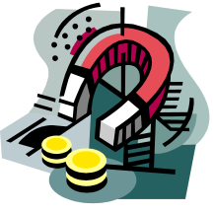
Some forces _____ need to act on ___ object by contact or ___ touching it, while other forces may act ___ a distance and do not make contact ____ the objects at all.
an, by, may, with, at

